Out Cast

Game Design Document

Based upon the JMF Screenlabs short story, Pure Blood.

Caerwyn Bartley | Elric Milton | O’Neil Khoshaba

# Table of Contents

Table of Contents 1

Project Overview 3

Relation to JMF Screenlabs 3

Relation to Pure Blood Story 3

Game Synopsis 3

Genre 3

Design Pillars 3

Mechanics 4

Mechanics List 4

Third-Person Controller 4

Camera Control 4

Player Movement 5

Spells 5

Power Discharge Bar 5

Power Discharge 5

Wall Build 5

Waypoint System 6

Waypoint Placement 6

Waypoint Removal 6

Waypoint Branching 6

Pedestrian System 7

Pedestrian Waypoint Navigation 7

Pedestrian Alert State 7

Pedestrian Player Detection 7

Cop System 8

Cop Patrol Waypoint Navigation 8

Cop Player Detection 8

Cop Alert State (Investigate Area & Move to Player Last Known Position) 8

Level Design 9

Vertical Slice 9

User Interface 10

Power Bar 10

Over-head Icons 11

Dialogue pop-ups 12

Level Design & Art 13

Level Design 13

Art 14

Feedback Log 15

Story. 16

Opening crawl 16

First paragraph (Lore) 16

Second paragraph (Story) 16

Story beats 16

NPC Dialogue 17

# Project Overview

## Relation to JMF Screenlabs

The game will mention that the story is adapted from the JMF Screenlabs’ short story 'Pure Blood' by Myles Blasonato and a link to the website and story will be provided on the main menu of the game, the game credits will also reflect this and encourage the player to read more short stories on the JMF Screenlabs’ website.

## Relation to Pure Blood Story

It is a reimagining of the universe of Pure Blood by taking the fundamentals of the stories world and building upon them by having the player take control of another caster in another location evading capture.

## Game Synopsis

Out Cast is a third-person stealth strategy game in which the player takes control of an unnamed caster who is attempting to reach a caster safe zone, the player is in danger of revealing their illegal powers. It is set during present day in a modern city.

## Genre

Third-person stealth strategy

## Design Pillars

**Stealth**

*Player hides both in plain sight as well as the shadows.*

**Oppression**

*Atmosphere is one of a personal dystopia afflicting Casters like the main character.*

**Strategy**

*Player must plan around difficult events to avoid capture.*

# Mechanics

## Mechanics List

* Third-Person Controller
  + Camera Control
  + Player Movement
* Spells
  + Power Discharge Bar
    - Power Discharge
  + Wall Build
* Waypoint System
  + Waypoint Placement
  + Waypoint Removal
  + Waypoint Branching
* Pedestrian System
  + Pedestrian Waypoint Navigation
  + Pedestrian Alert State
    - Pedestrian Navmesh Navigation to Cop
  + Pedestrian Player Detection
    - Pedestrian Update Player Last Known Position
    - Player Avoidance
    - Pedestrian Magic Detection
* Cop System
  + Cop Patrol Waypoint Navigation
  + Cop Player Detection
    - Cop Update Player Last Known Position
    - Cop Magic Detection
  + Cop Alert State
    - Cop Investigate Area
    - Cop Navmesh Navigation to Player Last Known Position

## Third-Person Controller

### Camera Control

#### Description

Using mouse axes, the player can control the movement, both vertical and horizontal, of the Third-Person Camera.

#### Relation to other mechanics

* Player Movement
* Power Discharge Bar

### Player Movement

#### Description

Ability for the player to control the character using the W (forward), A (left), S (backwards) & D (right) buttons.

#### Relation to other mechanics

* Camera Control
* Pedestrian Alert State
* Pedestrian Player Detection
* Pedestrian Update Player Last Known Position
* Cop Player Detection
* Cop Alert State
* Cop Update Player Last Known Position

## Spells

### Power Discharge Bar

#### Description

A visible bar on the user interface that is constantly filling. Once the bar is filled it triggers the power discharge event.

#### Relation to other mechanics

* Camera Control
* Power Discharge

### Power Discharge

#### Description

An event that will cause a particle burst and alert any pedestrians/cops in a certain vicinity.

#### Relation to other mechanics

* Power Discharge Bar
* Pedestrian Magic Detection
* Cop Magic Detection

### Wall Build

#### Description

Player uses up a certain amount of their Power Discharge Bar to place a wall that rises from the ground obstructing any pursuers (Cops). The wall can be placed at any position, and the player is provided a display of where the wall will be placed before they let go of the placement button.

#### Relation to other mechanics

* Power Discharge Bar
* Player Movement
* Pedestrian Update Player Last Known Position
* Pedestrian Magic Detection
* Cop Update Player Last Known Position
* Cop Magic Detection
* Cop Navmesh Navigation to Player Last Known Position

## Waypoint System

### Waypoint Placement

#### Description

Tool to place waypoints or add a new waypoint before/after the currently selected waypoint.

#### Relation to other mechanics

* Waypoint Removal
* Waypoint Branching
* Pedestrian Waypoint Navigation
* Cop Waypoint Navigation

### Waypoint Removal

#### Description

Tool to dissolve currently placed waypoints.

#### Relation to other mechanics

* Waypoint Placement
* Waypoint Branching
* Pedestrian Waypoint Navigation
* Cop Patrol Waypoint Navigation

### Waypoint Branching

#### Description

Tool to create a waypoint that isn’t directly connect to the previous waypoints. This new waypoint has a configurable chance to divert connect entities onto the new path.

#### Relation to other mechanics

* Waypoint Placement
* Waypoint Removal
* Pedestrian Waypoint Navigation
* Cop Patrol Waypoint Navigation

## Pedestrian System

### Pedestrian Waypoint Navigation

#### Description

System that controls the movement of pedestrians (entities) along the waypoints. When they meet the currently assigned waypoint, they automatically assign themselves to another waypoint that is either assigned as the next or previous waypoint.

Has configurable values for speed, rotation speed and distance to waypoint node and also is able to recognise branch waypoints and randomly (in relation to a random range) choose whether to continue along the current path or branch onto the new path.

#### Relation to other mechanics

* Waypoint System
* Pedestrian Alert State

### Pedestrian Alert State

#### Description

Pedestrian state where they break off of their current waypoint navigation, locate and walk towards the closest cop entity.

#### Relation to other mechanics

* Pedestrian Waypoint Navigation
* Pedestrian Navmesh Navigate to Cop
* Pedestrian Update Player Last Known Position
* Pedestrian Magic Detection
* Cop Alert State

### Pedestrian Player Detection

#### Description

Mesh that, when the player is inside, can detect the player in a ‘line of sight’ (Update Player Last Known Position), avoid them (Player Avoidance) and detect when magic is being used (Magic Detection).

#### Relation to other mechanics

* Player Movement
* Power Discharge
* Player Avoidance
* Pedestrian Magic Detection
* Pedestrian Update Player Last Known Position

## Cop System

### Cop Patrol Waypoint Navigation

#### Description

Cops can patrol (walk) between waypoints on a Navmesh.

#### Relation to other mechanics

* Waypoint System

### Cop Player Detection

#### Description

Cops can detect magic nearby, as well as receive the players last known location.

#### Relation to other mechanics

* Player Movement
* Power Discharge
* Pedestrian Navmesh Navigation to Cop
* Pedestrian Update Player Last Known Position

### Cop Alert State (Investigate Area & Move to Player Last Known Position)

#### Description

Cops can move to the players last known position and then search for the player (investigate area) for a short amount of time once they arrive at that position.

#### Relation to other mechanics

* Cop Player Detection
* Pedestrian Player Detection

# Level Design

### Vertical Slice

#### Vertical slice level requirements:

* Start area.
* Space to experiment with movement and learn the basics of evading cops.
* An NPC in a secluded location who teaches you a new spell (x2).
* Places where the players *optimal* strategy is to hide using the shrink spell, for example: behind food carts, cars, under a table... something like that.
* Pedestrians.
* Cops.
* End area (a safe zone of some kind).

# User Interface

### Power Bar

The power bar is displayed at the top of the UI and visualises the build up of magical power until it’s full, triggering the burst VFX and alerting pedestrians.

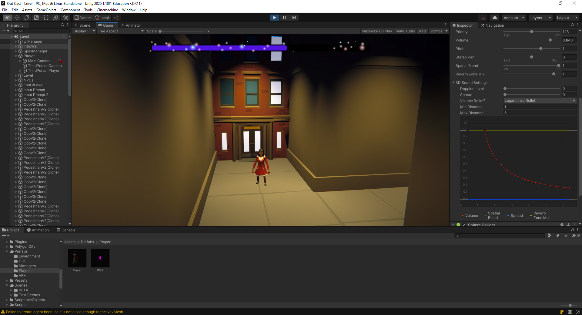

### Over-head Icons

Icons above the NPCs heads helps to visualise the various states they are currently in.

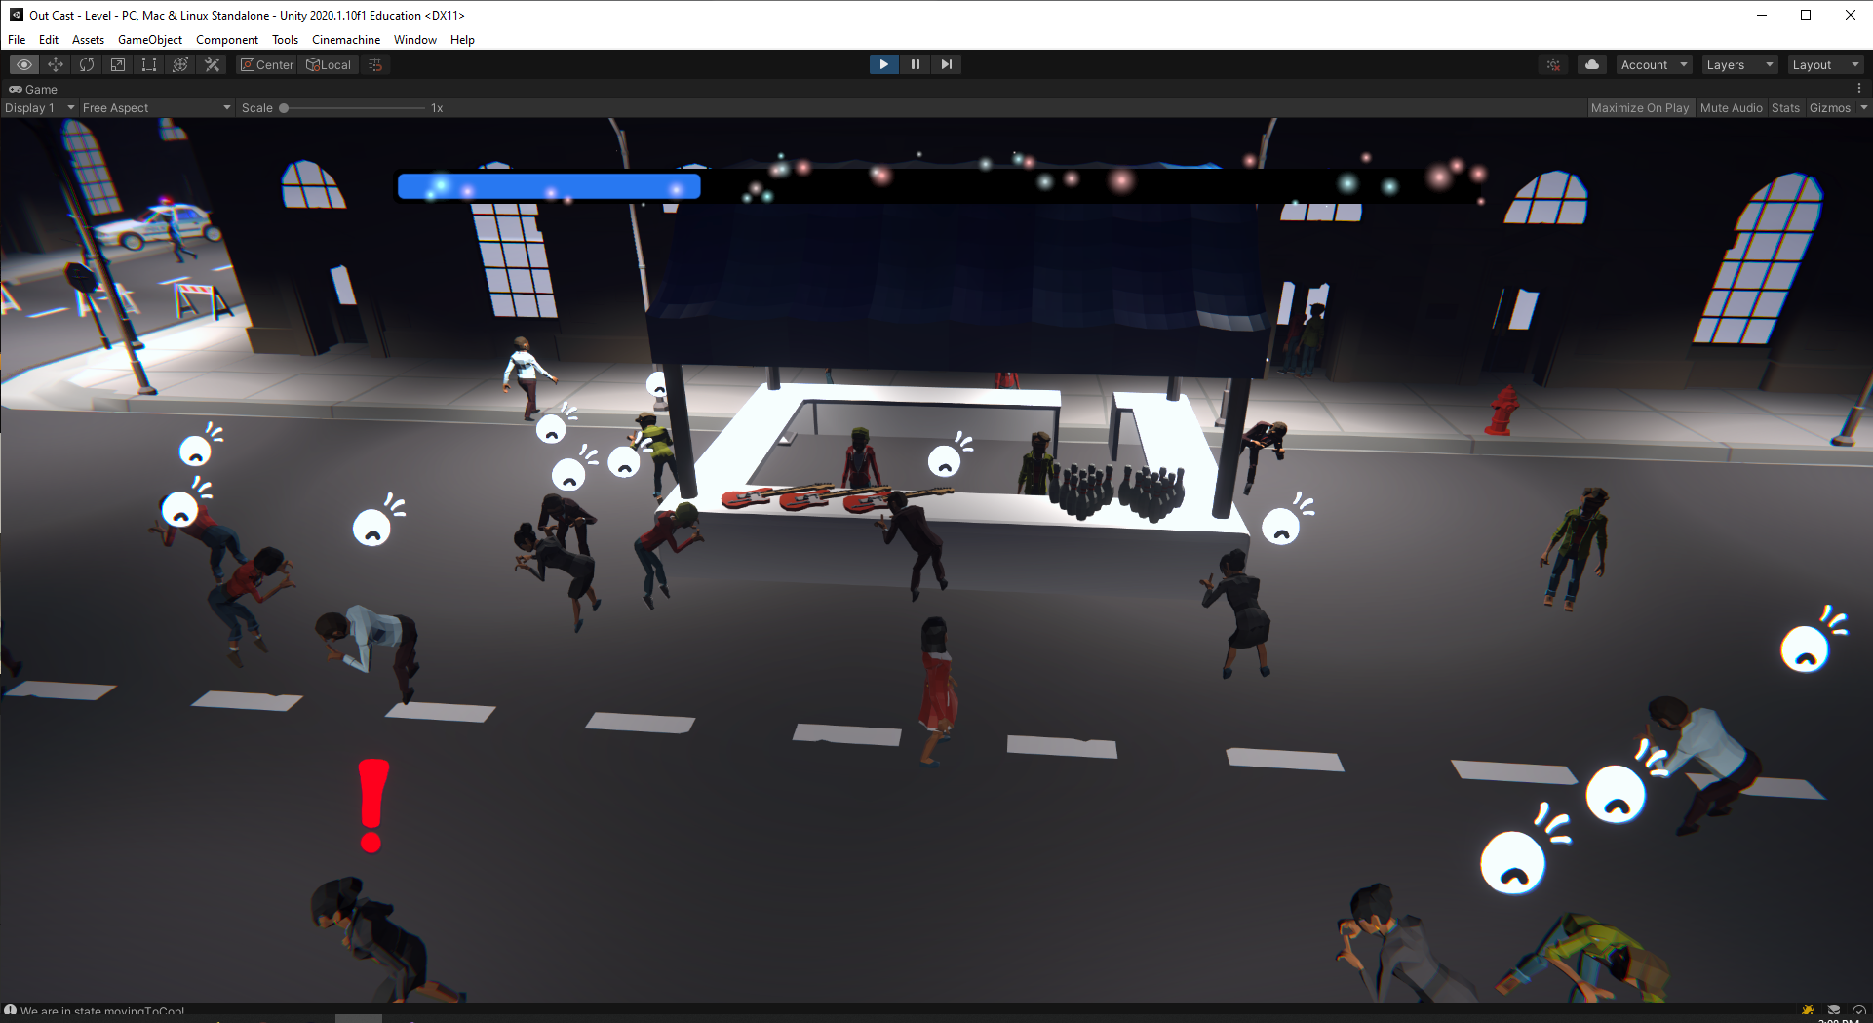

### Dialogue pop-ups

Dialogue is displayed as text box pop ups above the heads of helpful NPCs.

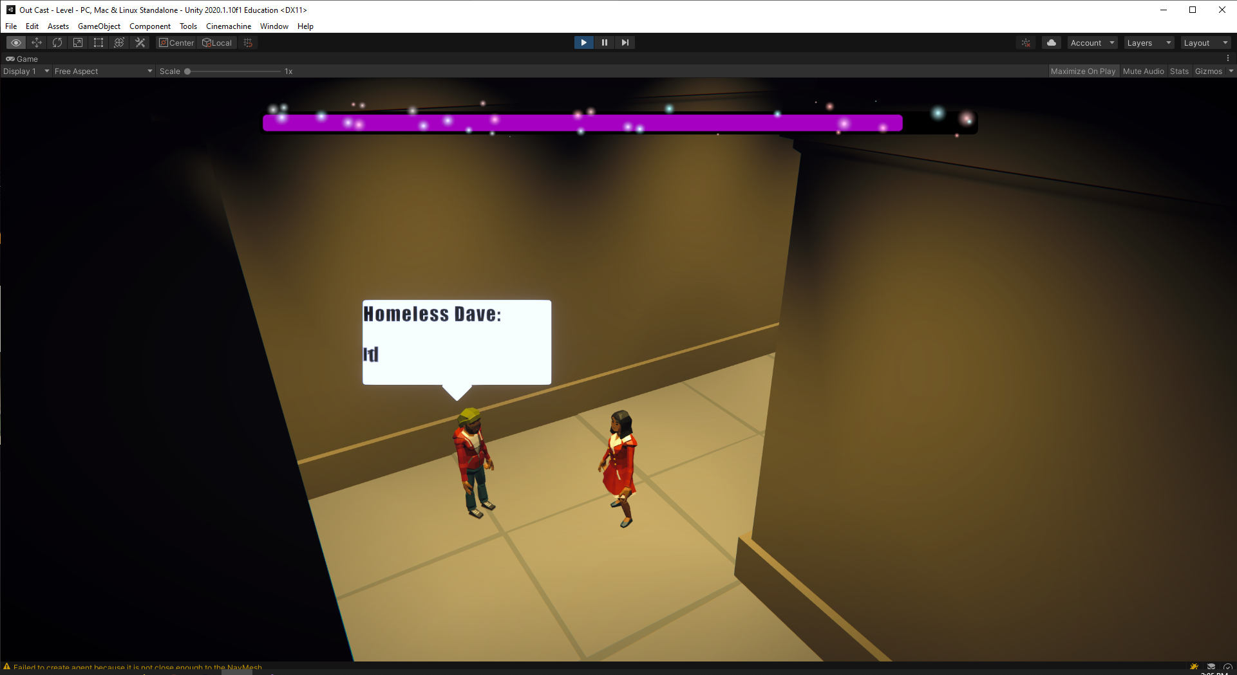

# Level Design & Art

### Level Design

The level was planned to be a small section of a city main street with a few alleys and a park for the player to explore and hide amongst.

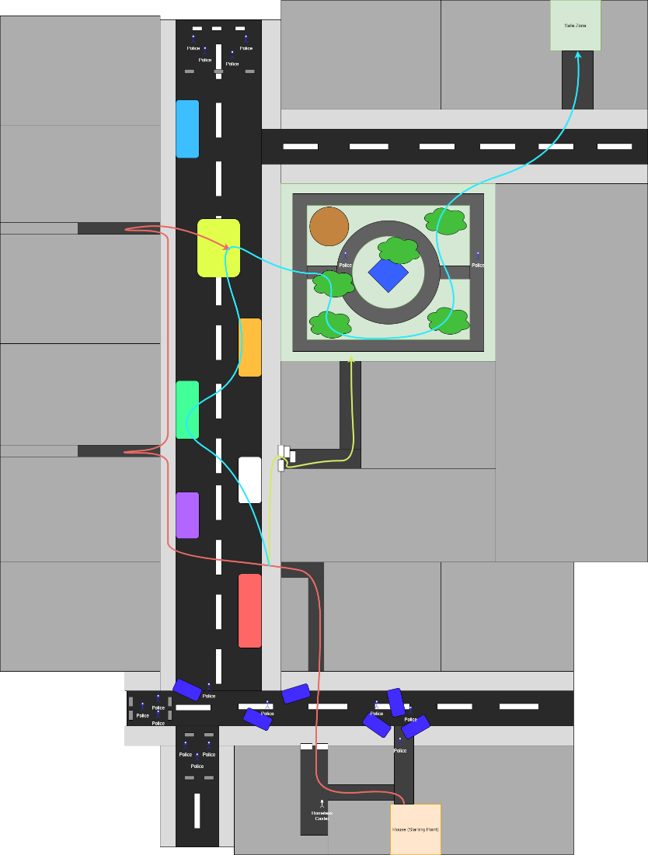

### Art

Art assets were taken from Synty studios Low Poly City asset pack, and were modified to fit the mood and style of our game.

Lighting and post processing were used to set the time of day to late evening and create an atmosphere of oppression.

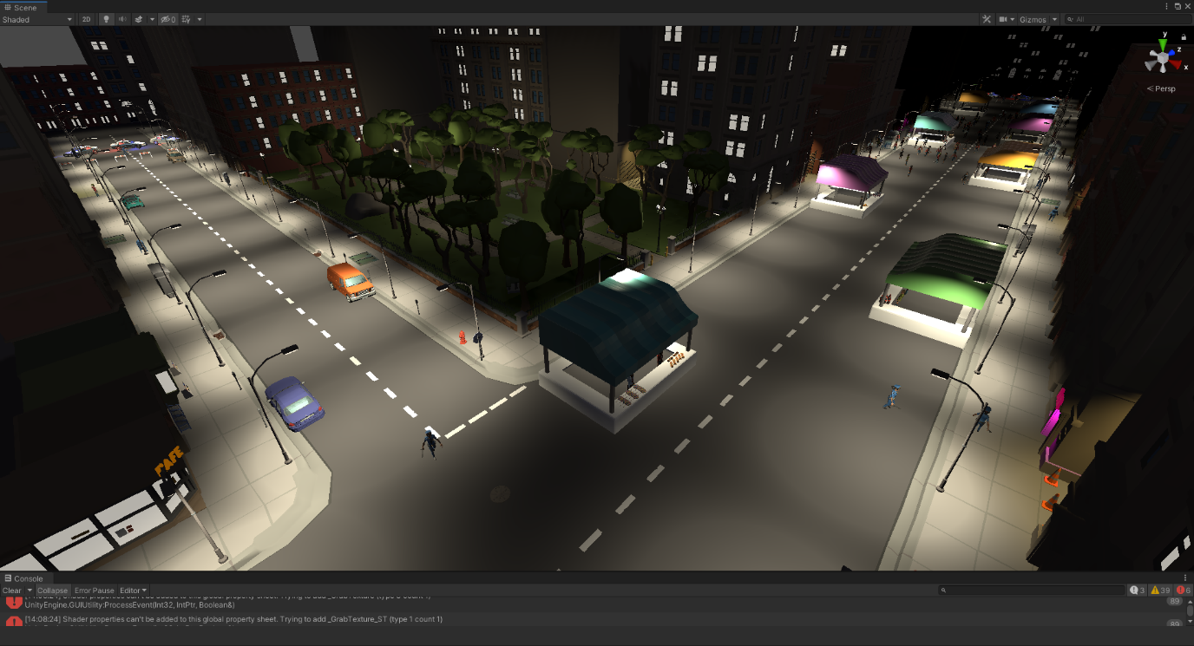

Lighting was also used to highlight areas of interest such as alleyways and hiding opportunities.

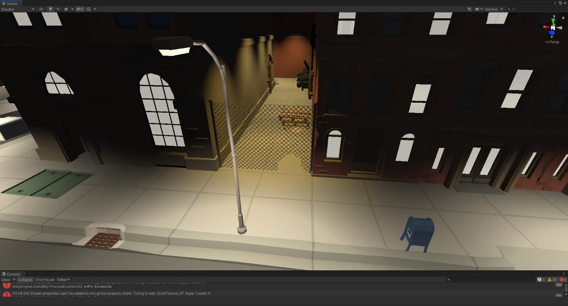

# Feedback Log

|  |  |  |  |
| --- | --- | --- | --- |
| Date | Name | Feedback | Implementation |
| 30/04/2021 | Francesco Blasonato | Gameplay looks nice but should emphasise the players oppression more | Added NPCs that move to alert cops & also dark mood lighting for emphasis. |
| 06/05/2021 | Myles Blasonato | Gameplay feels strong, AI needs work | Reworked AI and attempted to simplify state machine |
| 21/05/2021 | Kyle Gian | Pedestrians are a little bit broken | Need more time to fix, will implement post production. |

# Story.

### Opening crawl

This is presented similarly to the Star Wars scrolling text intro.

### First paragraph (Lore)

In ancient Mayan texts, magic is described as energy that is all around us. It’s what created our world. And that Casters where the people that could manipulate that energy. However, there are two variations to the bloodline. Those that delved into Pure Magic and those that delved into Dark Magic. Said to be a descendant of Satan The Dark Sorcerer, the first Dark Magic user, who has the ability to absorb other Casters’ magic, has arisen once again and caused all casters to fluctuate magic and reveal their identity’s.

### Second paragraph (Story)

After discovering that you’re a caster the homeless man who lives in the ally near your apartment reveals to you that he is a caster himself, you must now get to the safe zone that your friend told you about. To get there you must traverse through the town that has had recent encounters with casters so is on high alert, your best option is to use the festivities as cover get to this safe zone.

### Story beats

#### Beat 1

* Into crawl, sets up story to the player.
* The cops are raiding your home because then have been tipped off that you’re a caster a caster.
* You run outside to find them moving towards you, but a wall blocks them off.
* Run into homeless Dave down the ally.

#### Beat 2

* Homeless Dave tells you about a caster safe zone and that you must get there by finding one of the other casters that know it’s location.
* Search for one of the other casters to tell you the location of the safe zone and how to get there.

#### Best 3

* Find a caster to give you the location of the caster safe zone (Can be any of the 3rd beat NPC around the level).
* Caster tells you the location of the safe zone and the magic incantation you need to access it.

#### Beat 4

* Continue through the city to the caster safe zone.
* Reach the safe zone where a caster asks you to recite the incantation to gain access to the safe zone.
* The safe zone is revealed, and you enter.

### NPC Dialogue

These are presented as NPCs who speak to you as you approach them.

#### Homeless Dave Beat 2 NPC

Homeless Dave: Woah mate! those coppers just storming into your house like that, bloody bonkers.

Homeless Dave: Coppers are on high alert since the incident with the caster lass, not a good time to be one ay.

Homeless Dave: I’d say it’s time to leg it, there are other like us out there they’ll point you right way.

#### Groovy Terry Beat 3 NPC-In ally across from the park

Groovy Terry: How you do’n babe names Terry, Dave told me bout you.

Groovy Terry: Said the mans tryin’ to put you in a cage, No buena amiga.

Groovy Terry: The safe zones in a building across the way from the park.

Groovy Terry: I’ll teach you the incantation you’ll need to get though, and I'll send you on your way babe.

#### Conner Beat 3 NPC-In ally that connects to park

Conner: Psst you’re that caster Dave was talking about.

Conner: Some of you casters helped my sister get to a safe state a while back, I’m Conner by the way.

Conner: The safe zone is in a building off the main road across from the park.

Conner: Here they said that you need to recite what’s on this paper to get through to the safe zone.

#### Beat 4 NPC

Safe zone keeper: You say you’re a caster if that’s right preform the incantation in front of that wall and it will open to the safe zone.

Safe zone keeper: Once you do that your home free and I’ll seal it behind you.